

A

### Report

Ecommerce Site

BY: Soumitya Chauhan

### 16023014

Submitted to:

#### DEPARTMENT OF COMPUTER SCIENCE & ENGINEERING MVN UNIVERSITY, PALWAL

# Introduction

# Name: Soumitya Store1.0

# About:

This project is Single Vender Ecomm Store. Where just normal functionally is user an buy product and admin can post the product.

Login Authentication. This is Ecomm site and content management system, You can easily setup and customize it according to your needs. It is easy to use and manage. Multiple users can sign up and be able Buy Product. For the Password I have use Bcrypt to hash the password and store to Db

The main features of the application would be:

CLIENT SIDE

1. User Login authentication.
2. Stock status.
3. delivery tracking.
4. Multiple User login support

SERVER SIDE (ADMIN PANEL)

1. ADMIN Login authentication
2. Add Product
3. Stock Update
4. Delivery Tracking Update
5. CURD operation

TECHNOLOGY USED

* CSS
* JS
* Node JS
* React JS
* Mongo db
* Express JS
* InstaMojo (Payment Gateway)

DEPLOYMENT

* Heroku

Why I have use this Technology

React JS

React.js is an open-source JavaScript library that is used for building user interfaces specifically for single-page applications. It’s used for handling the view layer for web and mobile apps. React also allows us to create reusable UI components. React was created by Facebook.

**JSX**

In React, instead of using regular JavaScript for templating, it uses JSX. JSX is a simple JavaScript that allows HTML quoting and uses these HTML tag syntax to render subcomponents. HTML syntax is processed into JavaScript calls of React Framework.

NODE JS

Node.js is a free, open-sourced, cross-platform JavaScript run-time environment. And Event Driven and Work on Google V8 engine

BCRYPT

Many password solutions simply are not good enough and put your data and resources at risk. bcrypt is a password-hashing

CLIENT SIDE (WEB_APP):

* Category
* Banner
* Login/Signup
* Search
* Buy now
* My order
* Logout
* Out of Stock
* Order Status of user
* InstaMojo Payment Gatway
* Delivery tracking of user Product

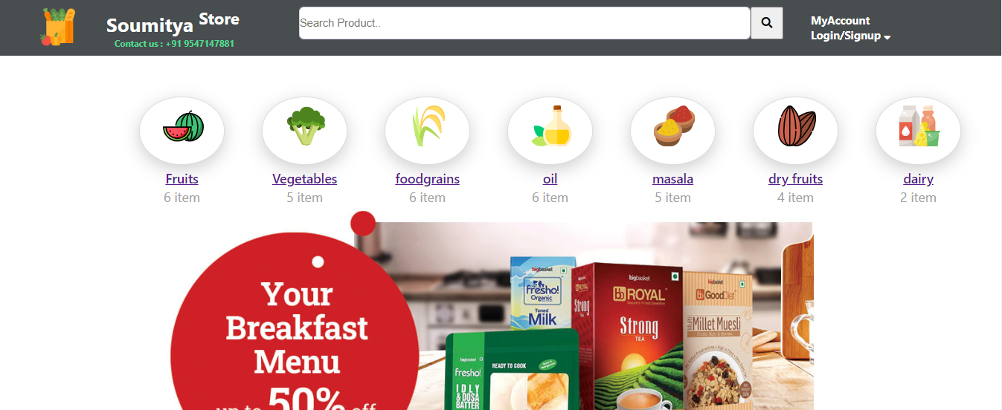

ADMIN PANEL (WEB_APP):

ADMIN can do CRUD operation

* Login/Signup
* Dashboard
* Add Product
* Mange Product
* Order
* Category
* Stock Update
* Delivery Update

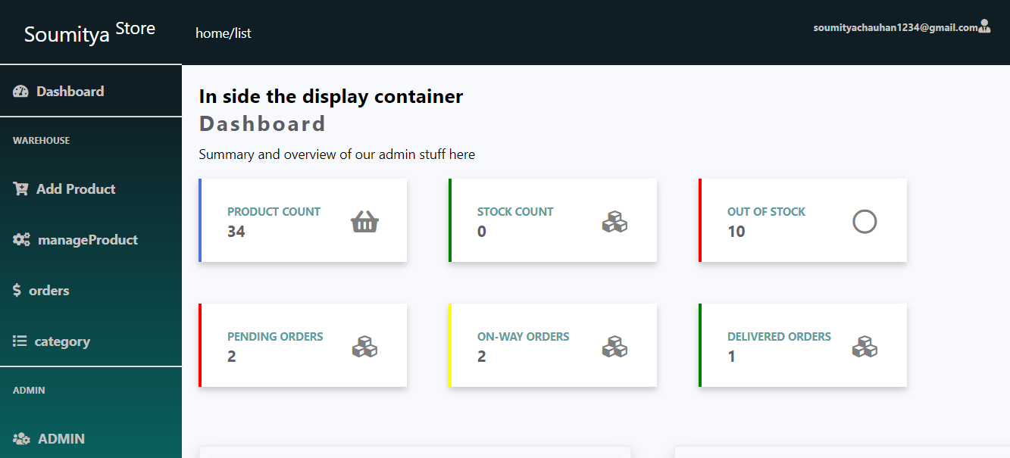

---------------------------------------------The End----------------------------------------------